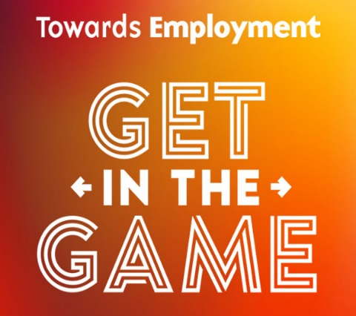
Towards Employment: Get in the Game 2019
At The Westin Cleveland Downtown
777 St Clair Ave NE

Yes - I/we would like to GET IN THE GAME at the following level. (Choose a level below)

Corporate  Sponsorship  Levels | Most Valuable Player  ($15,000) | Game  Changer  ($10,000) | Skill  Builder  ($5,000) | Goal  Setter  ($3,000)
Number of VIP Guest Seats | 20 | 10 | 8 | 6
Recognition in Event Materials – Save the Date and Invitation
Ad in Event Program | Full page Color | ½ page Color | ½ page B&W | ¼ page B&W
Recognition on TE website
Recognition in TE annual report
Inclusion in Social Media
Recognition from Stage
Name in “Stadium Lights”
Inclusion in Press Release
Branded Game Station
Tax Deduction | $13,400 | $9,150 | $4,400 | $2,550
For individual sponsorship opportunities, contact Adaora at aschmiedl@towardsemployment.org. Individual tickets go on sale August 1, 2019.

CONTACT INFORMATION:
Name
Address
City State Zipcode
Daytime Phone Type: Cell Work Home
Email Company Name
PAYMENT INFORMATION
Check enclosed for $ payable to Towards Employment. Please send invoice for $___________
Please charge my credit card $ Type: MC VISA Discover
Name on Card Exp Date Sec Code
Card# Signature
We are unable to attend but wish to donate our guest tickets to other Towards Employment fans.
No, I/We cannot sponsor Get in the Game at this time, but please accept our contribution of $
THANK YOU FOR YOUR GENEROUS SUPPORT
Save the Date Deadline is June 26
Invitation Deadline is July 21
Program Book Deadline is September 1
Please mail/email form and payment to:
Towards Employment: Get in the Game
Adaora Schmiedl, Director of Development & Marketing
1255 Euclid Avenue, Suite 300 | Cleveland | 44121
aschmiedl@towardsemployment.org | 216-696-7310

